Brittany Smith
CSD-310 Database Development and Use
Module 1.2 Assignment-GitHub Repository Setup

GitHub Repository Link:
https://github.com/britt10libra/csd-310.git

Local Directory Shot (see next page)
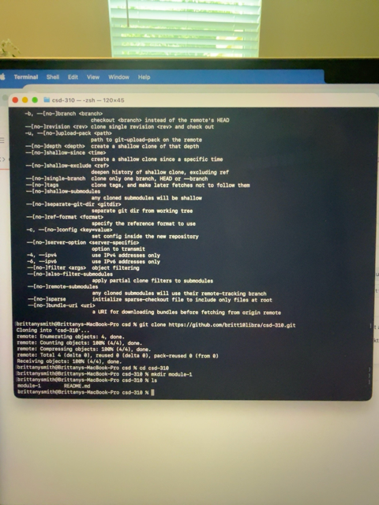
GitHub Repository Screenshot

